The Islamia University of Bahawalpur
Department of Information Technology



School mAnagement system

Student Name
Alisha Riaz
Session: Spring 2023 – 2027
Supervisor
Omer Riaz

Bachelor of Science in Information technology

This project is dedicated to The Planner, The Creator of the entire universe; The Merciful ALLAH, and his loving messenger Hazrat Muhammad (Peace Be Upon Him). ALLAH has given us the power to perform this task and facilitating every possible means to complete this project!

Specially Thanks!

I feel deeply obliged to my family, whose prayers and good wishes have enabled me to reach this stage. My success is the result of continuous guidance, invaluable feedback, and constant moral support provided throughout the session. The efforts made for students were not limited to projects only but continued consistently during the entire academic year.
We are truly grateful to all our teachers who have taught us during the session. Their dedication, sincere efforts, and kind behavior have always encouraged and motivated us to learn and grow. Their guidance and support have played a major role in our learning journey, and we extend our heartfelt thanks to each one of them.

Contents
Chapter 1 5
INTRODUCTION 5
1.1 Background 5
1.2 Problem Statement 6
1.3 Objectives 6
1.4 Importance of the Project 7
1.5 Scope and Limitation of the Project 7
Chapter 2 8
LITERATURE REVIEW 8
2.2.1.E-School for Management 9
E-School for Teacher 9
Chapter 3 12
METHODOLOGY 12
Chapter 4 16
Requirement Analysis 16
Sequence Diagram 26
Activity Diagram 27
Chapter 5 28
Design and Implementation 28
Admin Panel Interface 31
Student Panel Interface 50
Teacher Panel Interface 54
Parent Panel Interface 60
Chapter 6 65
Testing and Evaluation 65
Chapter 7 68
Conclusion and Future Work 68

Chapter 1

INTRODUCTION

1.1 Background
When you ask the school to enter the electronic world in which he asked to electronic advantages make you processions electronic era which has become all the world is in it and that makes you continuously with students and teachers quickly Here you require a Website so that this site covers the needs of teachers and students at one time so that it is Students special site where watching the monthly marks obtained at the school and also can request permission in the case not to go to school and that teacher who can put signs and writes reports on each student activity, duties and violin can be to the director of the school that is watching all the students and teachers in terms of absence and attendance and also can see that all the observations and monitors all complaints and reports and so in a short time and quickly. Hence we can say that this site facilitates all administrative tasks within and outside the school with ease. Web pages will often require more screen space than is available for a particular display resolution. Most modern browsers will place a scrollbar (a sliding tool at the side of the screen that allows the user to move the page up or down, or side-to-side) in the window to allow the user to see all content. Scrolling horizontally is less prevalent than vertical scrolling, not only because such pages often do not print properly, but because it inconveniences the user more so than vertical scrolling would (because lines are horizontal; scrolling back and forth for every line is much more inconvenient than scrolling after reading a whole screen; also most computer keyboards have page up and down keys, and many computer mice have vertical scroll wheels, but the horizontal scrolling equivalents are rare). When web pages are stored in a common directory of a web server, they become a website.
A website will typically contain a group of web pages that are linked together, or have some other coherent method of navigation. The most important web page to have on a website is the index page. Depending on the web server settings, this index page can have many different names, but the most common is index.html. When a browser visits the homepage for a website, or any URL pointing to a directory rather than a specific file, the web server will serve the index page to the requesting browser. If no index page is defined in the configuration, or no such file exists on the server, either an error or directory listing will be served to the browser. A web page can either be a single HTML file, or made up of several HTML files using frames or Server Side Includes (SSIs).
Frames have been known to cause problems with web accessibility, copyright, navigation, printing and search engine rankings, and are now less often used than they were in the 1990s. Both frames and SSIs allow certain content which appears on many pages, such as page navigation or page headers, to be repeated without duplicating the HTML in many files. Frames and the W3C recommended alternative of 2000, the <object> tag, also allow some content to remain in one place while other content can be scrolled using conventional scrollbars. Modern CSS and JavaScript client-side techniques can also achieve all of these goals and more. When creating a web page, it is important to ensure it conforms to the World Wide Web Consortium standards for HTML, CSS and other standards. The W3C standards are in place to ensure all browsers which conform to their standards can display identical content without any special consideration for proprietary rendering techniques. A properly coded web page is going to be accessible to many different browsers old and new alike, display resolutions, as well as those users with audio or visual impairments. Usually, Web pages today have become more dynamic. Web pages are dynamic, which is generated from the server-side when asked to do so, and then serve the end user. These types of web pages usually do not have a fixed link, or a fixed address, associated. Today, it can be seen in many popular forums, and online shopping, even on Wikipedia. This practice is designed to reduce the amount of static pages instead of storage with associated information in the database pages. Some search engines may have difficulty in indexing web pages and dynamic web pages, so it can offer static pages in those cases.

1.2 Problem Statement
The problem currently facing many schools is the management of courses. Here, the teacher does not properly handle their workload, and sometimes the courses are not offered on time. The number of students who must study the course is not followed. The main problem is to managing the teachers work and courses scheduling. Also, in the school the student cannot know the marks that the student get it on the exam, but when the student goes to school and also, the teacher cannot be assured that the student has a sign seen by the parent and guardian also cannot, to know his son's performance in school, but he must go to school and ask for it.

1.3 Objectives
Main Objective: - Build a web site that support mobile working to manage the different school activities.
Sub Objective:

- Track student schedules.
- Hold records of the student's attendance.
- Enrolling new students.
- Help parents to follow up to his son's performance in school.
- Help the teacher to facilitate access to parents and introduce them to the extent of deficiencies at the student process

1.4 Importance of the Project
The school as institution to provide students, children and young person's to science and education, and is a building where students learn reading, writing, mathematics, science and various other studies, what are the features of the school and its goals and where are the various teaching centers? What are the facilities and equipment that requires availability in the school We must therefore provide students with the electronic knowledge, because the world is with electronic features and became dependent on technology dramatically and through the presence of the Web site of the school makes it easier for students to deal with websites and opens a large field of learning and enter this world full of information and useful things that make it benefit significantly and it also helps to understand the field of development through research and discovery of new information in the materials that can also cultures through the discovery of new methods of learning and teaching methods In Pakistan, the student must have a knowledge of technology and science, which has become the easy way to reach the outside world in order to raise the educational level of the student and also to send a message to all the world that the Palestinian student can keep up with the electronic world quickly despite the wars that are exposed and that he could be scientifically advanced in the world.

1.5 Scope and Limitation of the Project
The Website Design School, to provide an easy way to get the student information. On the website was chosen PHP programming language in order to be available to him from the ease and durability in this language. This project is based on any operating system where the programming language is open source which helps to make changes to what it is compatible with any school.
This project will be applicable in every country of this world, then it will involve all schools. We will make the testing process in many Schools.

Chapter 2

LITERATURE REVIEW

2.1 Introduction
This chapter review and identify concepts and related work about E-School.

2.2 E-School, School Management System Strategy
E-School is a complete school information management solution. Today's schools need to manage more information than ever before. Without a solid internal infrastructure for teachers, administrators and Parent’s to share data, critical school and student information can be lost, or worse leading to a host of problems that can effect of a school's image and endurance. To remain competitive, school needs a simple solution that can run individual function, connect their entire operation, use the web as a key communication tool and simplify day to day operational responsibilities, giving staff more time with students.
E-School automates various scheduling activities of school and optimizes the use of premium resources. Concerned authorities can now easily and seamlessly use the system to create timetables, otherwise a time consuming and tedious task.

2.2.1.E-School for Management

- Single points school management software.
- Enable internet front-end for the school.
- Connect with Parents effectively
- Build and Manage community of parents, teachers and students
- Manages all administrative records with zero redundancy
- Achieve best possible resource optimization
- Automate all operational functions like Attendance, Exam scheduling and class scheduling.
- Automatic generation and regeneration of information with dynamic substitute management.

E-School for Teacher
- Complete attendance automation.
- Interact with parents efficiently and effectively.
- View analytical reports
- Private and Internal messaging system.
- View own attendance.
- View Student Record.
- View parent’s record.
- View Class that has been assigned to him/her.
- View Noticeboard of School online.

2.2.3 E-School for Student

- Real time exposure for better learning.
- Interaction with other admin’s, teachers and parents.
- View own attendance.
- View Class schedule in advance.
- View current events and holidays at school.

2.2.4 E-School for Parent

- Get latest updates about school through Noticeboard.
- Share knowledge and views with admin’s and school through various features like private messaging.
- Get connected with schools effectively and easily
- Interact with teachers through private messaging system.
- know status about her/his child through attendance etc.

2.3Technologies used on E-School

HTML: is the standard markup language used to create web pages. Web browsers can read HTML files and render them into visible or audible web pages. HTML elements form the building blocks of all websites. HTML allows images and objects to be embedded and can be used to create interactive forms. It provides a means to create structured documents by denoting structural semantics for text such as headings, paragraphs, lists, links, quotes and other items.

CSS: is a Web page derived from multiple sources with a defined order of precedence where the definitions of any style element conflict. The Cascading Style Sheet, level 1 recommendation from the World Wide Web Consortium (W3C), which is implemented in the latest versions of the Netscape and Microsoft Web browsers, specifies the possible style sheets or statements that may determine how a given element is presented in a Web page. And describes how HTML elements are to be displayed on screen, paper, or in other media.

PHP: is an open source server-side language which is used for creating dynamic web pages. It can be embedded into HTML. PHP is usually used in conjunction with a MySQL database on Linux/UNIX web servers. It is probably the most popular scripting language. And it is a widely-used general-purpose scripting language and interpreter that is freely available. A full explanation of all the PHP tags.
MySQL database: MySQL is the world's most popular open source database. With its proven performance, reliability and ease-of-use, MySQL has become the leading database choice for web-based applications, used by high profile web properties including Facebook, Twitter, YouTube, Yahoo! and many more.

Chapter 3

METHODOLOGY

3.1 Introduction

The third chapter states the methodology used to reach the objectives of the project. The framework in which software is designed, developed, and maintained is known as the Software Development Life Cycle (SDLC). It shows the steps, phases, milestones, and evolution of the software development process. There are many types of models used in software design and development. Among them are the spiral models, rapid development model, Evolutionary model, waterfall model, prototyping model, etc.

3.2 Methodology

Prototyping Model has been used to develop this application. The Prototyping model is a technique for quickly building a function but incomplete model of the information system. There are several kinds of prototypes but they all intend to reduce risk by building a quick and dirty replica or mockup of the intended system. It can be used to demonstrate technical feasibility when the technical risk is high. It can also be used to better understand and elicit user requirements. In either case, the goal is to reduce risk and limit costs by increasing understanding of proposed solutions before committing more resources, as shown in figure 1.

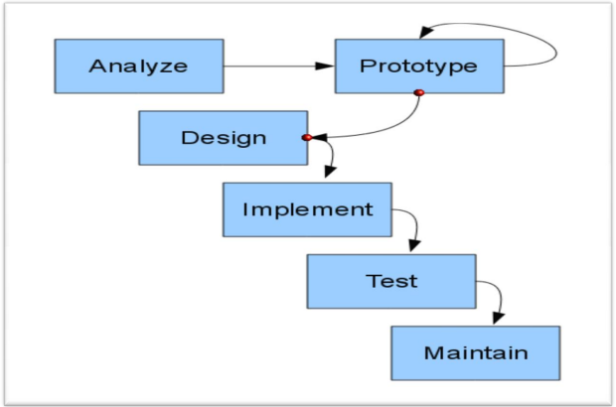

3.3 Prototype Model

3.3.1 Advantages of Prototyping

  - Reduces development time.
  - Reduces development costs.
  - Requires user involvement.
  - Developers receive quantifiable user feedback.
  - Facilitate system implementation since users know what to expect.
  - Results in higher user satisfaction.
  - Exposes developers to potential future system enhancements.

3.3.2 The Process of Prototyping
  - Identify basic requirement: Determine basic requirements including the input and output information desired. Details, such us security, can typically be ignored.
  - Develop initial prototype: The initial prototype is developed that includes only user interfaces.
  - Review: The customers, end-users, examine the prototype and provide feedback on additions or changes.
  - Revise and enhancing the prototype: Using the feedback, both the specifications and the prototype can be improved. This method involves a series of iterations and refinement until the prototype product is a fully working system, and the user is satisfied.
3.4 Reason of using Prototype Model
- Users are actively involved in the development.
- Since in this methodology a working model of the system is provided, the users get a better understanding of the system being developed.
- Since in this methodology a working model of the system is provided, the users get a better understanding of the system being developed.
- Since in this methodology a working model of the system is provided, the users get a better understanding of the system being developed.
- Errors can be detected much earlier.
- Quicker user feedback is available leading to better solutions.
- Missing functionality can be identified easily.
- Confusing or difficult functions can be identified Requirements validation, Quick.
- implementation of, incomplete, but functional, application.

3.5 Phases in prototype Model

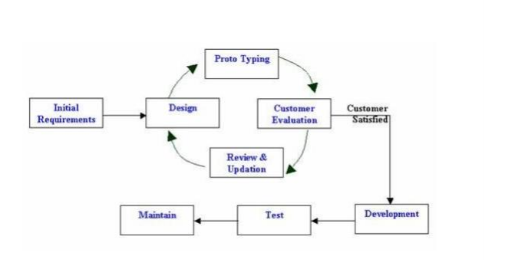
Phase 1: Identify some requirements to begin with: Get lists of some major requirements which define the need for the new system including the main input output information.

Phase 2: Develop initial prototype: Develop a basic initial prototype which only has UI screens.

Phase 3: Review the prototype: End users and SME’s work and examine the prototype and provide feedback for improvements/enhancements.

Phase 4: Revise and enhance the prototype: Scope is changed based on feedback from end users and the prototype is enhanced and refined to accommodate user feedback.

Chapter 4

Requirement Analysis

4.1 Introduction
This chapter will provide a full description of the system and its users. Then it depicts the functional and non-functional requirements that have been collected using several methods from brainstorming, interview and e-surveys. After determining the most important requirements, requirement analysis was adopted using several tools such as use-case diagram, sequence diagram and activity diagram.

4.2 System description E-school (SMS)
It is a system serving the student and the teacher and parents This electronically where it will be the work of a Web application, The idea of this system to enable the student to enter the site and get information that given by the school electronically and also keep pace with all that is happening again in the school in general It also operates a system for parents who can follow their children through this system in terms of teacher's supervisor's names on their students' attendance and monthly, as well as teacher observations own sons and students can also follow the administration of the website And also seeing the school quota schedule for the student as well as attendance rates and absenteeism from school, Where parents can see them for the student And also the daily absences for the school system, with the possibility of determining the cause of absences for each student, also for teachers and staff, And also can through the site to be communication between teachers and parents in order to follow the activities of the students inside the school.

4.3 User description

There are four main users for the proposed system; these are Admin, student, teacher and the parent. Each user can perform several different functions during the use of the system. These functions were determined according to the design of the proposed system and a user-friendly functions to make the system more effective and efficient. Figure 4-1 summarizes the functions performed by each user.

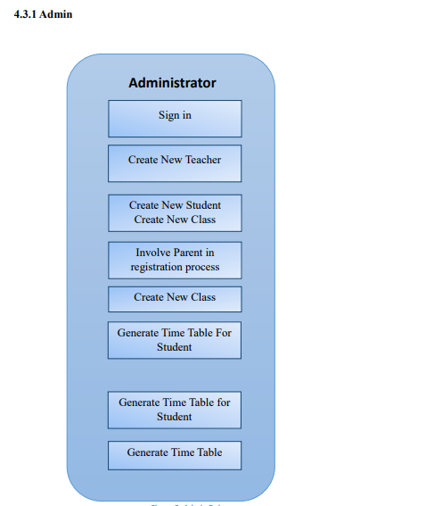

As shown, the admin can Create New Teacher and Create New Student and Involve Parent in registration process and Create New Class and Generate Time Table for Student and Generate Time Table for Teacher.

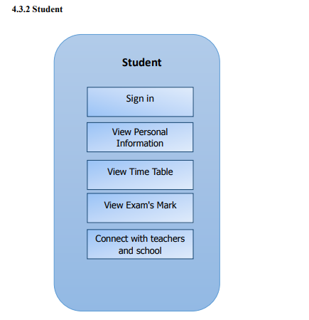
View Daily Attendance

As shown, the student can View Personal Information and View Time Table and View Daily Attendance and Connect with teachers and school management System.

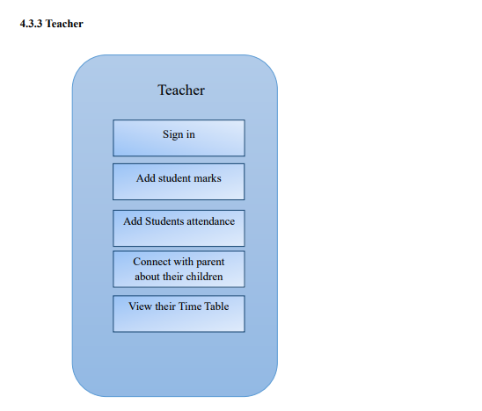
As shown, The Teacher can add student marks And Add Students attendance And Connect with parent about their children And View their Time Table.

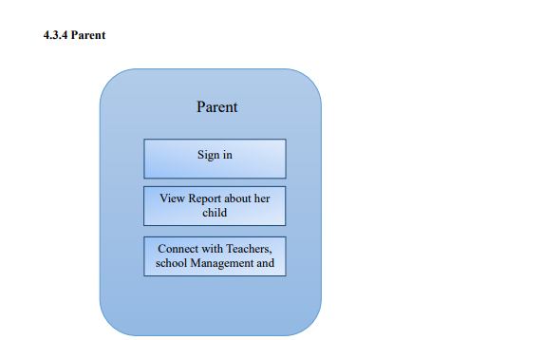
As Shown, The Parent can sign in And View Report about her child And Connect with Teachers, school Management and other parent.

4.4 System Requirement
Before creating any website or a mobile App, it is necessary to visualize the layout, design and all features intended to be incorporated. In addition, how users will interact with each page and icon and how the website/App should perform (behavior, load time etc.). Requirements are the necessary attributes in the system, a statement that identifies a capability, characteristic or quality factor of the system in order to have value and utility to the users. Once the requirements are set, developers can initiate the other technical work including system design, development, testing, implementation, and operation. For any system, there are functional and non-functional requirements to be considered while determining the requirements of the system. The functional requirements are user “visible” features that are typically initiated by stakeholders of the system, such as generate report, login, and signup. On the other hand, nonfunctional requirements are requirements that describe how the system will do what it is supposed to do, for example, security, reliability and maintainability.

4.4.1 Functional Requirement
4.4.1.1 Admin

  - Create, edit and delete student account.
  - Create, edit and delete teacher account.
  - Create, edit and delete parent account.
  - Publish news on noticeboard for users (Teacher, Student, and Parent).
  - Store, edit, delete, calculate and print student's information.
  - Add Classes and Subject to the teachers.
  - Change user information.
  - Search student's information per name and per ID.
  - Create, edit, delete and print class schedule/time table.
  - Change System settings.
  - Change their account's information.

4.4.1.2 Teacher
  - Create, edit and delete student account.
  - Add Student's attendance per Subject.
  - Connect with Admin’s, student and parent.
  - View news on noticeboard for users (Teacher, Student, and Parent).
  - Change their account's information.

4.4.1.3 Student

  - View their attendance.
  - Ask their teacher and the admin
  - View class and subjects and teachers of that subjects.
  - View news on noticeboard for users (Teacher, Student, and Parent).
  - Change their account's information.

4.4.1.4 Parent

  - View the attendance of their children.
  - View news on noticeboard for users (Teacher, Student, and Parent).
  - Change their account's information.

4.4.2 Non-Functional Requirement
4.4.2.1 Security
The system have accounts for its users and only authorized users can access the system with username and password. The passwords are encrypted using a PHP function sha1 ().
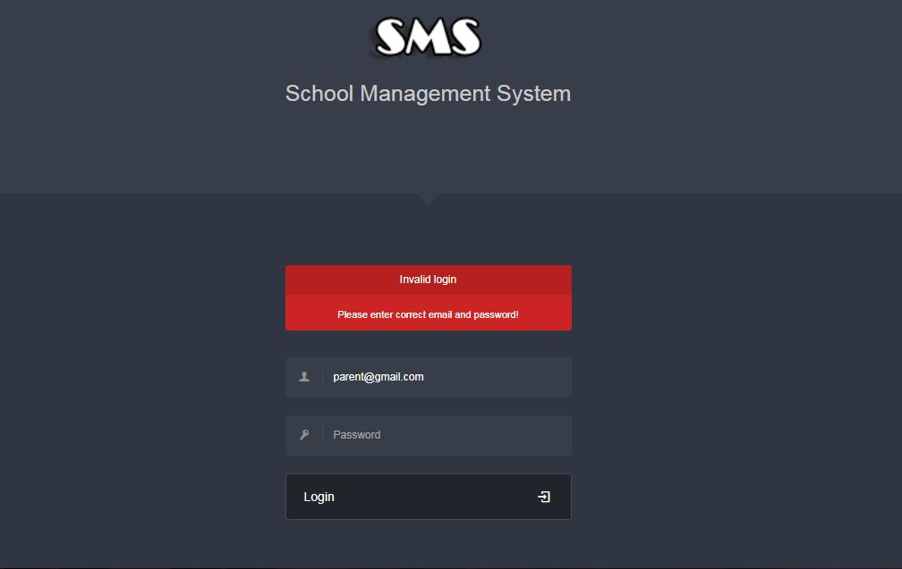

4.4.2.2 Performance Easy tracking of records and updating can be done.
4.4.2.3 Availability
The system are available to users anytime, anywhere, just need a PC and Internet Connection. Also the system work in multiple web browsers like (Chrome, Mozilla, Opera, and Internet Explorer).

4.4.2.4 User Friendly The system have a friendly user interface and the system very interactive.
4.5 System Analysis
This part contains the analysis of the functional and non-functional requirements using use-case diagrams, and use-cases details. In addition, the interactive behavior of the activities is analyzed using sequence diagrams and activity diagrams.
4.5.1 Use case Diagram
This part contains the analysis of the functional and non-functional requirements using use-case diagrams, and use-cases details.
- Admin
The Admin can do After Login process the following function as shown in figure7:
• Add Teacher include (Modify/Delete).
• Add Student include (Modify/Delete).
• Add Parent include (Modify/Delete).
• Add Class include (Modify/Delete).

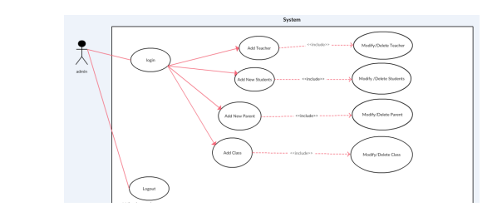
- Student
The student can do After Login process the following function as shown in figure8:
• View Personal Information.
• View Timetable.
• View Courses schedule.
• View Personal Details.
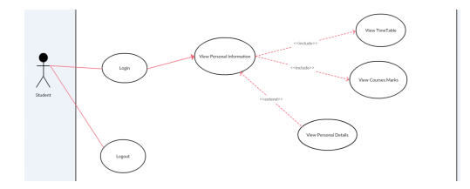

- Teacher
The Teacher can do After Login process the following function as shown in figure9:
• Add Attendance.
• Student’s information.
• Modify or delete student information.

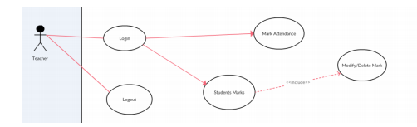
add

- Parent
The Parent can do After Login process the following function as shown in figure10:
• Generate Report.
• Show their child attendance.
• Show their child class schedule.
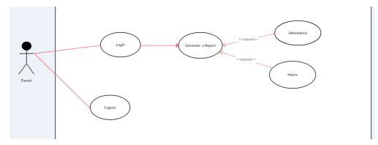
Class schedule

Sequence Diagram

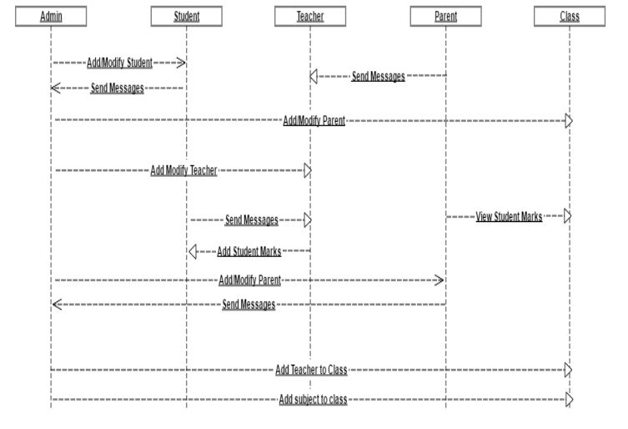

Activity Diagram

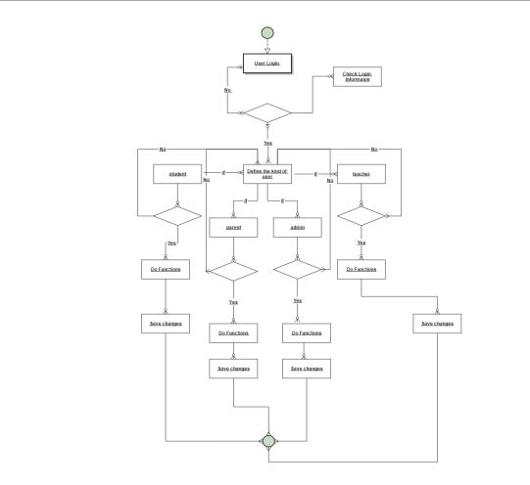

Chapter 5

Design and Implementation

This chapter explains the design and implementation phases of the system. It depicts the class diagram, ER diagram and database schema the System. Moreover, the implementation phase combines the requirements, design phase outputs, and process them using the appropriate
technologies.
5.1 Analyze Phase
During the analyze phase, we determine the requirement of the project and get in touch how we can improve the school's performance, also we determine how implement the school's need's to help them to get professional work.
5.2 Build A Prototype.
In this phase, the tools used in developing the prototype and the developed system are described:
5.2.1 Programming Tool
The system are developed using web development techniques (HTML5, CSS3, JavaScript,
JQuery) that let us design the system layout such as login form, tables, panels and colors, then
implement UI/UX element's such as :
• Make the system ease to use.
• Make the system ease to learn.
• Choose the website color's carefully to enhance user interfaces
Then, make the system dynamic using programing tools (PHP v7, MYSQL DBMS) it’s let us
store the user's information in the database and view it in the webpages using PHP v7.
5.3 Design Phase
During the design phase, the relationships between classes was designed and analyzed using the
class diagram. After that, the database schema was developed to illustrate the mapping of the
data. Finally, the
5.3.1 Class Diagram
To illustrate the relationships and source code dependencies among classes, class diagram was
developed. In this context, the class defines the methods and variables in an object, which is a
specific entity in a program or the unit of code representing that entity.

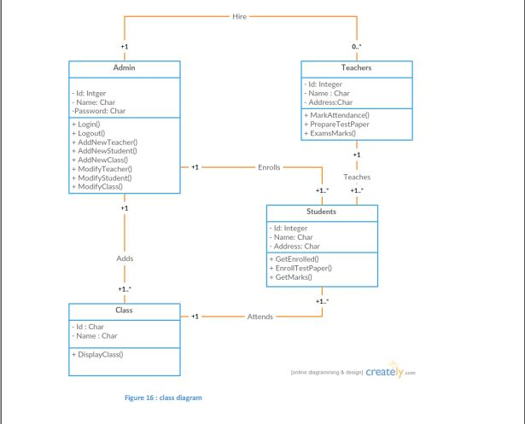
5.3.2 Database Schema:
A database schema is the skeleton structure that represents the logical view of the entire
database. It defines how the data is organized and how the relations among them are associated.
It formulates all the constraints that are to be applied on the data.
The system has five database tables as shown in Figure .Each table contains an ID and several
different attributes related to different functions in the system.

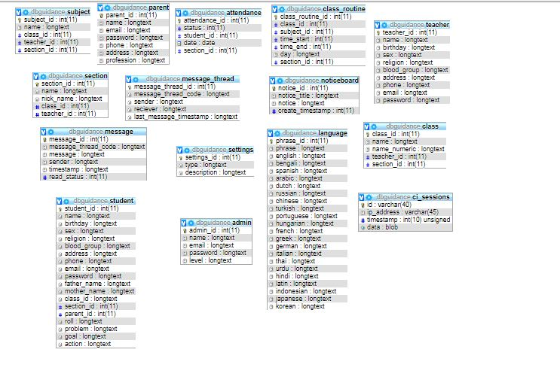

5.4 Implementation Phase
After developing the databases of the system, the implementation phase emerges and through
this phase, several activities and techniques were used to develop the website and mobile App, as
shown in blew. The development of the website starts with designing the website structure using
HTML5, then the style of the website was designed using CSS3. After that, enhanced user
interfaces and dynamic website were developed using JavaScript and JQuery. Later on, the
website contents and databases were managed through the use of PHP7. Finally, the panorama
was incorporated in the website.

Admin Panel Interface

5.5.1 Login Page:

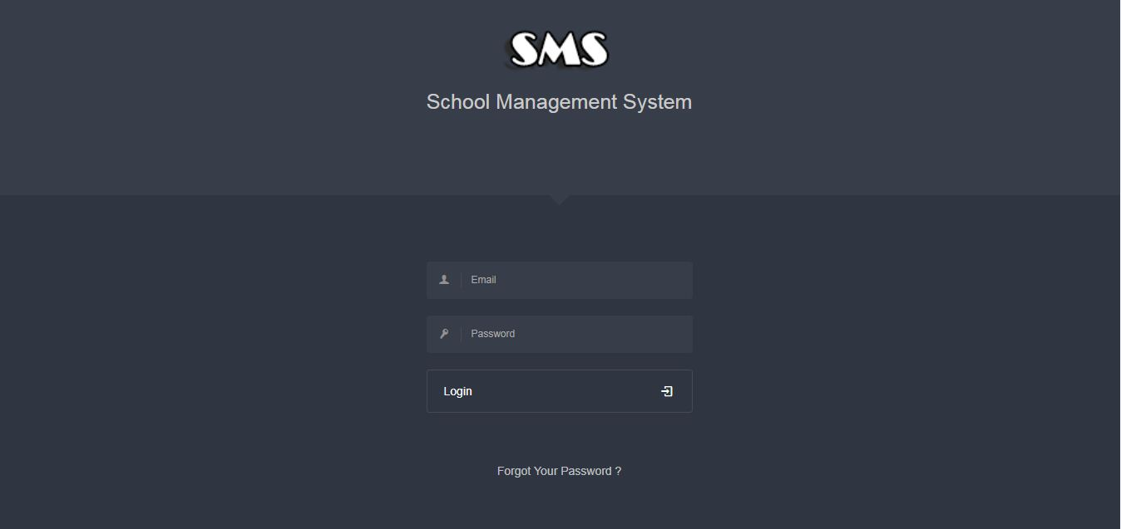

5.5.8 Send New Private Message:

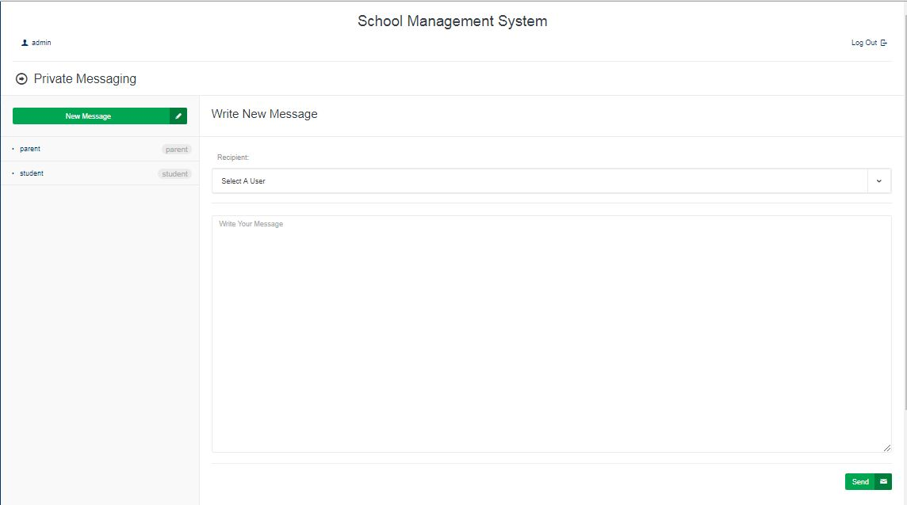

Student Panel Interface

5.6.1 Login Page:

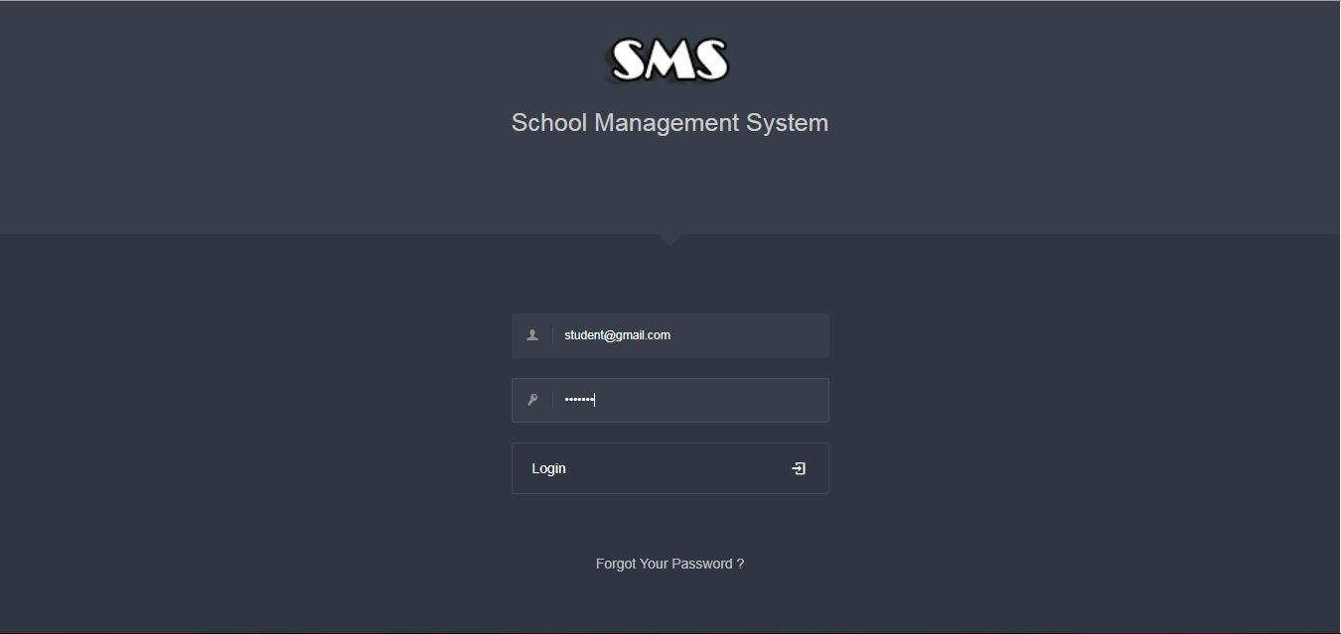

5.6.7 Send New Private Message:



Teacher Panel Interface

5.7.1 Login Page:

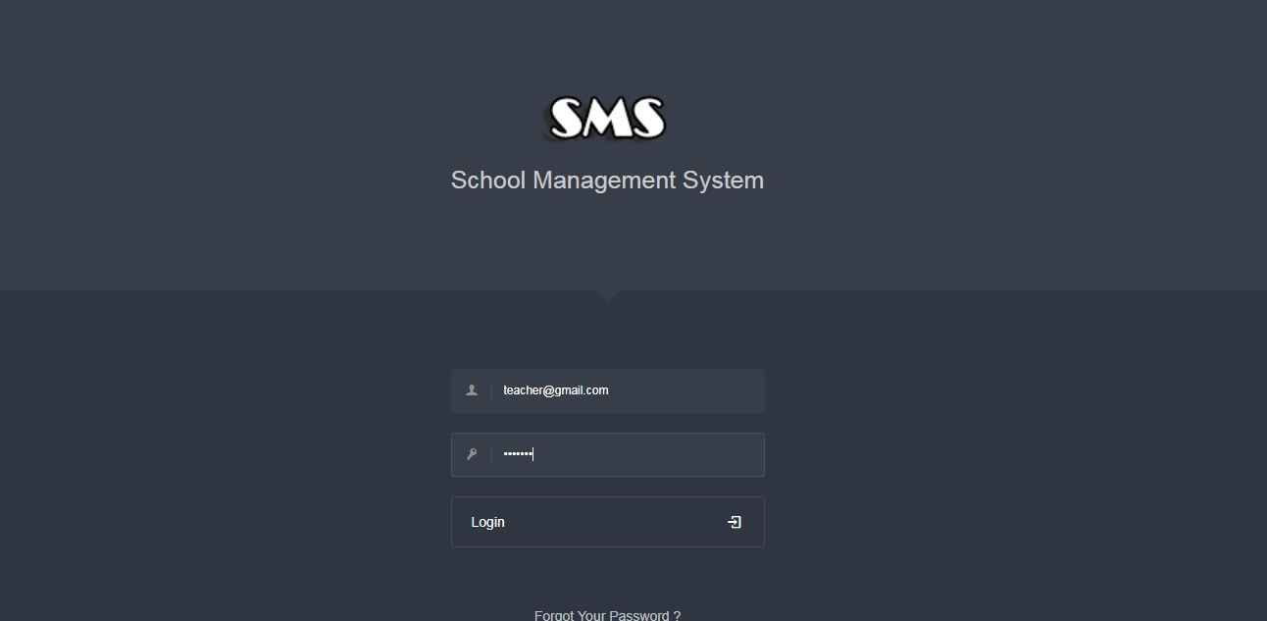

Parent Panel Interface

5.8.1 Login Page:

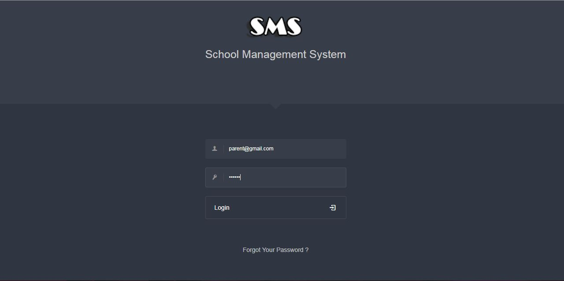

Chapter 6

Testing and Evaluation

This chapter illustrates the last two phase of the project the testing and evaluation phases. In the
testing phase, the performance testing and functionality testing performed. In addition, the
evaluation was performed through this steps School Manager, Teacher, Student, and Parent.
6.1 Testing
Two types of testing were performed to test the website and how it supports mobile working. These
tests were mainly performance testing and functionality testing.
6.1.1 Performance testing
The website was tested on Firefox browser using an online tool called GTMetrix, which
analyzes web pages according to different rules by giving each rule a weigh, and then evaluate
the score of each rule for the website. The rules tested by this tool is indicated in Table blew.

1. Make fewer HTTP requests | 2. Remove duplicate JavaScript and CSS
3. Use a CDN | 4. Configure ETags
5. Avoid empty src or href | 6. Make AJAX cacheable
7. Add Expires headers | 8. Use GET for AJAX requests
9. Compress components with GZip | 10. Reduce the number of DOM elements
11. Put CSS at top | 12. Avoid HTTP 404 (Not Found) error
13. Put JavaScript at bottom | 14. Reduce cookie size
15. Avoid CSS expressions | 16. Use cookie-free domains
17. Make JavaScript and CSS external | 18. Avoid AlphaImageLoader filter
19. Reduce DNS lookups | 20. Do not scale images in HTML
21. Minify JavaScript and CSS | 22. Make favicon small and cacheable
23. Avoid URL redirects

6.1.2 Functionality Testing
All functions in the application, database connection, forms used to enter data for submission,
editing, getting or deleting information from users were tested. Developers performed the test of the website. Some functionality requirements were tested during the test:
6.1.2.1 Security Testing
Security was tested by pasting internal URL directly into browser address bar without login. SQL
injection SQL MAP tool was used to test all pages in website. Also when the user (Admin,
Teacher) need to edit marks or information to other user if he edit the id in URL the system will
redirect to logout page or home page.
Ex: (student.php?userid=120110220) if the user try edit the id number to access to other user
information or other hacking.
6.1.2.2 Database Testing.
Data consistency is very important. Data integrity and errors while editing, deleting, modifying
the forms or do any DB related functionality were checked. Moreover, the entire database queries were checked to be executed correctly, data is retrieved correctly and even updated correctly.
6.2 Evaluation
Since the system has four users whose opinion about the system is very important, a sample of
student, teacher, parent, and school manager were consulted to evaluate the website.
6.2.1 Usability Evaluation
To evaluate the system based on the users (student, teacher, parent, admin).

6.2.2 Users Evaluation
In this evaluation process, we go to the school in the 'Nuserat' and distribute thirty questionnaires
and we get just 20 from it as shown blew (9 student, 6 teacher, 3 teacher, 2 admin).

Strongly agree | agree | Neutral | Disagree | Strongly  Disagree
Easy to use | 5 | 2 | 5 | 3 | 5
Easy access to  the functions  of the system | 4 | 8 | 4 | 8 | 1
Age  completion | 8 | 2 | 5 | 1 | 4
Help me  tracking the  student | 2 | 2 | 8 | 5 | 1
Help us to  concatenation  within the  school | 10 | 5 | 2 | 2 | 1

Chapter 7

Conclusion and Future Work

7.1 Conclusion
In recent years, with the pace of technological development, people have become more and more demanding in terms of quality of life, and the schools managers in recent years look to improve a performance in their schools to get the highest rate of knowledge and experience in their student.

7.2 Future Work
Some ideas and features can be considered as a future work for this project. These features can be summarized in the following points:

• Let the student take a testing exams Online.
• Let the student take an online certification.
• Bank of question per subject.
• Let teacher add a question to the bank of question.
• Let parent concatenation with other parents.
• Let admin add new classes.

The End

